**LAB-2**

**Question 1**

A student studying computer science at a college is examined by the practical work during the course and the final written examination. Each component of the assessment carries a maximum of 50 marks. The following rules used by the examiners in preparation of result. A student must score a total of 40% or more in order to pass. A total mark of 39% is moderated to 40%. However, each component must be passed with a minimum mark of 15. If a student scores 40% or more but does not achieve the minimum mark in one component is given a technical fail of 39% (This mark is not moderated to 40%).

Design a suitable Java class Student and display the marks and result of 5 sample students.

**CODE:**

import java.util.Scanner;

public class q1

{

public static void main (String args[])

{

Scanner in = new Scanner(System.in);

int n,i;

float t,l,total;

System.out.print("Enter no:of Students: ");

n=in.nextInt();

for(i=0;i<n;i++)

{

System.out.println("Student "+(i+1)+": ");

System.out.print("Enter Theory Marks: ");

t=in.nextFloat();

System.out.print("Enter Lab Marks: ");

l=in.nextFloat();

if(t>50 || l>50)

System.out.println("One component mark exceeds 50");

else

{

if(t<15 || l<15)

System.out.println("Failed");

else

{

total=(t+l);

if(total==39)

{

total=40;

System.out.println("Passed");

}

else if(total>=40)

System.out.println("Passed");

else

System.out.println("Failed");

}

}

System.out.println();

}

}

}

**OUTPUT:**

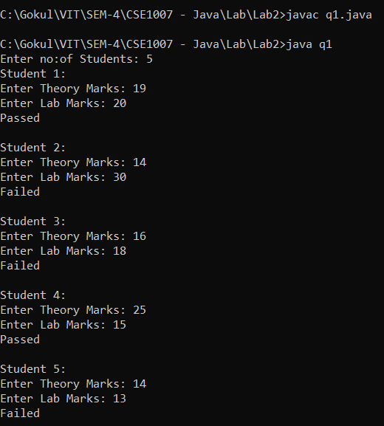

**Question 2**

The electrical resistance R of a cylindrical wire with length L (in meter) and diameter d (in meter) can be computed from the area A of its diameter (m2) and the resistivity Ρ of the material (rho, meter times Ohm). The formula: R = Ρ (L / A)

Compute the electrical resistance of a wire with length 1m and a diameter of 1mm for copper (Ρ = 1.78*10-8) and for silicon (Ρ = 2300)

**CODE:**

import java.util.Scanner;

public class q2

{

public static void main (String args[])

{

Scanner in = new Scanner(System.in);

int type;

double R,L,D,A,P;

System.out.println("1.Copper(1.78*10^-8) 2.Silicon(2300)");

System.out.println();

System.out.print("Enter type of wire: ");

type=in.nextInt();

if(type==1)

P=1.78*(Math.pow(10,-8));

else

P=2300;

System.out.print("Enter length in meters: ");

L=in.nextDouble();

System.out.print("Enter diameter in mm: ");

D=in.nextDouble();

D=D/1000;

A=3.14*(Math.pow(D/2,2));

R=P*(L/A);

R=Math.round (R * 100.0) / 100.0;

System.out.print("Resistance: "+R+" ohm");

}

}

**OUTPUT:**

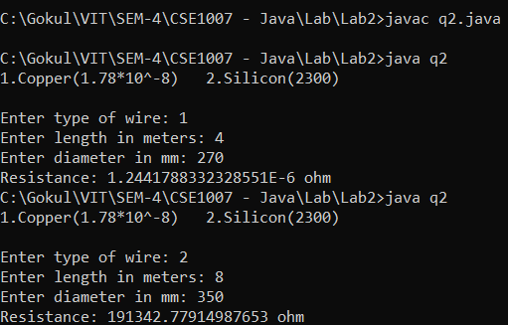

Silicon

Copper

**Question 3**

A man takes a job for 30 days. His pay for the first day is Rs.25/. His pay for the second day is Rs.50/. and for the third day is Rs.100/. Each day’s pay is twice his pay of the previous day. Write a program to find his total pay for 30 days.

**CODE:**

import java.util.Scanner;

public class q3

{

public static void main (String args[])

{

Scanner in = new Scanner(System.in);

int days, d, pay=25, total=0;

System.out.print("Enter no:of days: ");

days=in.nextInt();

d=days;

while(days>0)

{

total=total+pay;

pay=pay*2;

days--;

}

System.out.println("Total after "+d+" days: "+total);

}

}

**OUTPUT:**

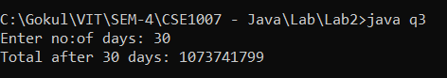

**Question 4**

In order to attract its customers, a jewellery shop gives a silver coin to its every 100th customer and a gold coin to every 250th customer. If a customer is eligible for both silver and gold coin, he gets then only gold coin. Design a Java application that gets all customer names and prints only the customer’s name who wins either a silver coin or a gold coin. For the sake of auditing purpose, it should also print the number of customers won silver coin or gold coin.

**CODE:**

//Silver for every 2nd customer and Gold for every 5th customer

import java.util.Scanner;

public class q4

{

public static void main (String args[])

{

Scanner in = new Scanner(System.in);

int n,i,silver=0,gold=0;

String[] names=new String[100];

System.out.print("Enter no:of customers: ");

n=in.nextInt();

System.out.println("Enter names of "+n+" customers: ");

for(i=0;i<=n;i++)

names[i]=in.nextLine();

System.out.println();

System.out.println("Winners:");

for(i=1;i<=n;i++)

{

if(i%2==0 && i%5==0)

{

gold++;

System.out.println("Customer-"+i+" : "+names[i]+" -Gold");

}

else if(i%2==0)

{

silver++;

System.out.println("Customer-"+i+" : "+names[i]+" -Silver");

}

else if(i%5==0)

{

gold++;

System.out.println("Customer-"+i+" : "+names[i]+" -Gold");

}

}

System.out.println();

System.out.println("No:of Silver Winners: "+silver);

System.out.println("No:of Gold Winners : "+gold);

}

}

**OUTPUT:**

